ProjectName Standards

# UI Design Standards

## Client supported standards

### Browsers

* Microsoft Edge
* Chrome

### Resolution/Screen Size

* TBD

## Design Element and Accessibility Links

* Link 1
* Link 2

Utilize Bootstrap elements when updating and creating new Pages and elements. Code for elements and how to implement them can be found at the UI link above. New elements created after the link above was finished will be put into this document.

## Style Guide

### Fonts

* Regular Text: Tahoma, Arial

### Colors

### Date Format

* Jan 1 2023

### Name Format

Last Name, First Name MI

### Hover Text

### Hover Cursor

## Page Elements

### Page Title

* This element always goes on top of the Breadcrumbs

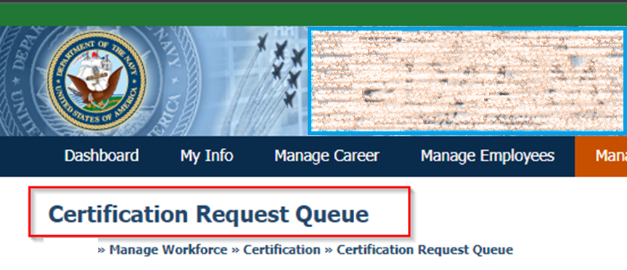

#### CSS

**(this styling is included in the PageTitle class already)**

Font-family: Tahoma, Arial  
Font-size: 20px  
Font-weight: bold

#### HTML

<h1 class="PageTitle">Certification Request Queue</h1>

### Breadcrumbs

* Last title in the breadcrumb is hyperlinked to the corresponding page

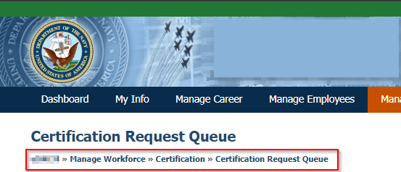

#### HTML

<div class="Breadcrumbs" id="Breadcrumbs">ProjectName » Manage Workforce » Certification » <a href=”#">Certification Request Queue</a></div>

### Tables

* https://devProjectName.devcontract.local/Channels/navyProjectName/Diagnostics/UIComponents/SimpleDataTable

#### Format/Style:

* Table header – Use <caption>Title</caption>
* Table column/row headers – Use <thead></thead> to group headers together
  + Sorting
    - Asc or Des
    - Which column(s)?
* Table Body – Use <tbody></tbody> to group the body of the table together
* Table Footer – Pagination?

**If no Data, show message**

### On Page Alerts/Validation

* https://devProjectName.devcontract.local/Channels/navyProjectName/Diagnostics/UIComponents/Alert
* Bootstrap Alerts
  + Red – Need Attention?
  + Green – Successful Action
  + Yellow – Notification/Important Information?

### Queues

* Toggle:
  + Pending
  + Processed – Include dropdown to show applications/requests/etc within the past 30/60/90/All Days

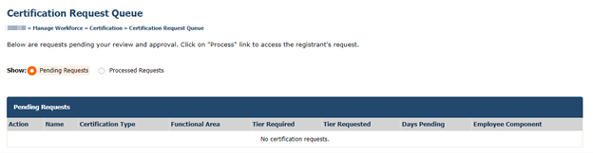

### Confirmation Page

* If directed to a confirmation page instead of a modal, the following screenshots capture data in tables for their respective modules. Validation messages at the top will vary depending on module as well.
  + Certification submission: 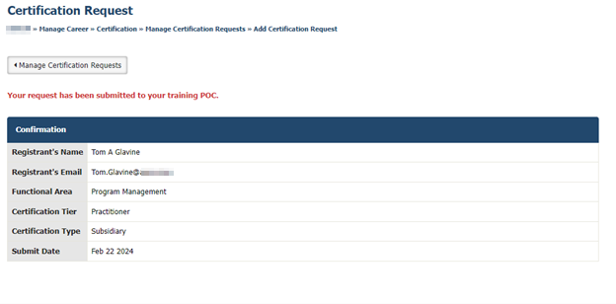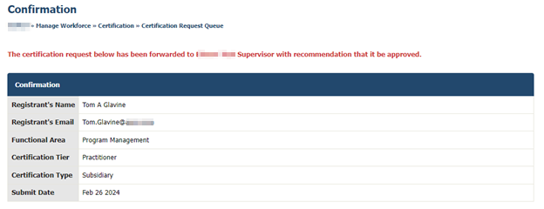 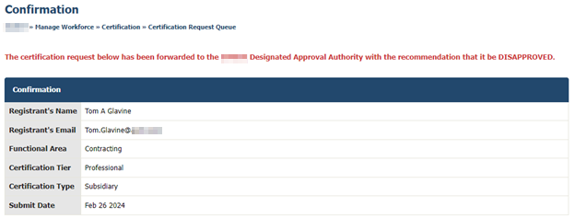

### Modal Popups

#### Alert

#### Confirmation of Action

#### Withdraw

#### Error

#### Delete

#### Validation

### Info Icons

* + Info Icon
    - Tooltip with description on hover



* Modal
  + Modal shows on click of Info Icon displaying information pertaining to specific feature.

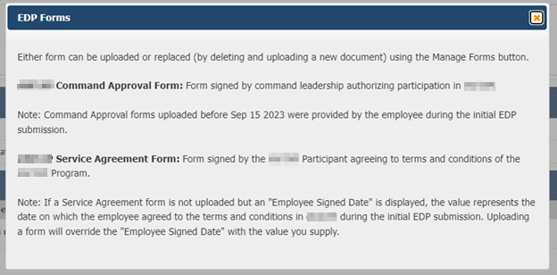

### Buttons

* https://devProjectName.devcontract.local/Channels/navyProjectName/Diagnostics/UIComponents/Button
* Ok/Save/Cancel/Back/Action Name/Etc
  + Style for each type
  + Modal
  + Form Related

 - Bootstrap

* + Search

- Bootstrap “primary”

* + Return to previous page



* + Action Button (View Transcript, Add New, Etc)

### Workflow sections

* Roles shown in Workflow are dependent on the specific module’s Workflow, or it follows the Workflow setup via the APM/Certification Manage Approval Workflow modules.
* Circles and lines show Completed (solid blue), Current (blue outline with blue circle within), and Future (empty circle with grey outline).

### History/Approval sections

* Styles

### Forms

* Styles
* TBD
* Text Areas with Counter

### Search feature

* Results size determined by System Param (Default 200?)
* Red Bootstrap Alert – Full width



### Text Formatting (ex. Last, First MI)

### Document Upload

* Design
* Storage/File Retention
* File Types
* Size Limits
* Delete logic

## Naming Conventions

## Email Templates

## User Access Criteria

## Dashboard

## Reports

### Table Headers

* Header will say “Email” when email address is included in the report data.

# Technical Design Standards

### Database

#### Stored Procedure Naming

##### Non-module specific Report

usp_ProjectName_Rpt_[name of report]

##### Module specific Report

usp_Rpt_[module]_[name of report]

### Search

* The system should display a validation message if none of the criteria are input and the search is triggered.
* The system should allow the search results to be ordered based on type of information.
* Clicking the employee’s email address will allow you to send an email via the computer’s default email program.
* If no information present in the system for an employee, the system shall display nothing for those information fields (vs a default value like “N/A”).
* The search results will only display the number of employees based on the system parameter value.
* If there are more results than the parameter setting, the system should display a message.
* The search results will be returned in alphabetical order of Employee Last name by default. “If Employee Name is included in search results, the search results are sorted by Employee Last Name ascending by default.”